Iran still stalling as nuclear deal deadline looms: watchdog

BY [**FREDRIK DAHL**](http://blogs.reuters.com/search/journalist.php?edition=us&n=fredrik.dahl&)

**VIENNA** Thu Nov 20, 2014 8:09am EST

* [inShare](javascript:void(0);)2
* **Share this**
* **Email**
* **Print**

http://s4.reutersmedia.net/resources_v2/images/btn_articleslide_previous.pnghttp://s4.reutersmedia.net/resources_v2/images/btn_articleslide_next.png

[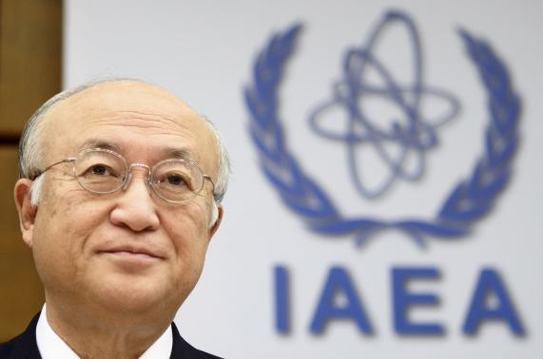](http://www.reuters.com/article/slideshow/idUSKCN0J40Z020141120#a=1)

[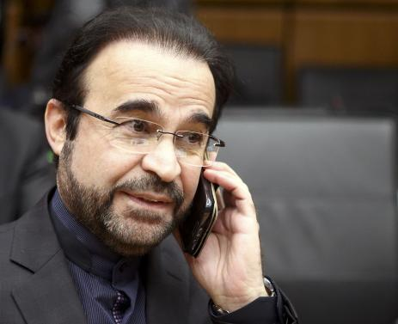](http://www.reuters.com/article/slideshow/idUSKCN0J40Z020141120#a=2)

1 OF 2. International Atomic Energy Agency (IAEA) Director General Yukiya Amano waits a board of governors meeting to commence at the IAEA headquarters in Vienna November 20, 2014.

CREDIT: REUTERS/HEINZ-PETER BADER

**RELATED NEWS**

* [Kerry travels to Vienna on Thursday for nuclear conference: spokeswoman](http://www.reuters.com/article/2014/11/20/us-usa-iran-nuclear-idUSKCN0J413X20141120)

**ANALYSIS & OPINION**

* [UKIP looking for next advance](http://blogs.reuters.com/macroscope/2014/11/20/ukip-looking-for-next-advance/)
* [Novel suit to determine if soldiers can sue over wartime terrorism](http://blogs.reuters.com/alison-frankel/2014/11/10/novel-suit-to-determine-if-soldiers-can-sue-over-wartime-terrorism/)

**RELATED TOPICS**

* [World »](http://www.reuters.com/news/world)

(Reuters) - [Iran](http://www.reuters.com/places/iran?lc=int_mb_1001) has yet to explain suspected atomic bomb research to the U.N. nuclear agency, its head said on Thursday, just four days before a deadline for a comprehensive deal between Iran and six world powers to end the 12-year-old controversy.

After nearly a year of difficult diplomacy, Washington is pushing for agreement on at least the outline of a future accord and U.S. Secretary of State John Kerry will attend talks with [Iran](http://www.reuters.com/places/iran?lc=int_mb_1001), France, Germany, Britain, Russia and China on Friday.

But Yukiya Amano, director general of the International Atomic Energy Agency, made clear it was far from satisfied, saying it was not in a position to provide "credible assurance" Iran had no undeclared nuclear material and activities.

The accord is intended to set limits on Iran's atomic activities in return for an end to international sanctions that have seriously hurt its oil-dependent economy.

As one of the conditions, Western officials say Iran must stop stonewalling the IAEA investigation into allegations Iran may have worked on designing a nuclear-armed missile, although some experts feel this should not be a deal-breaker.

"Iran has not provided any explanations that enable the agency to clarify the outstanding practical measures," Amano told the U.N. agency's 35-nation board of governors.

He was referring to information Iran was supposed to have given the IAEA by late August concerning allegations of explosives tests and other activity that could indicate preparations for developing nuclear bombs.

"I call upon Iran to increase its cooperation with the agency and to provide timely access to all relevant information, documentation, sites, material and personnel," Amano said.

Iran denies any intention of seeking atomic weapons, saying its nuclear program is aimed at generating electricity.

While the powers want Iran to scale back its uranium enrichment program - and thereby lengthen the timeline for any covert bid to assemble nuclear arms - the IAEA is investigating allegations of past research on designing an actual bomb.

Even though it has long been clear that the IAEA's inquiry would not be completed before the target date for a deal with the powers, Western diplomats had hoped for more progress by now.

Israel and hawkish U.S. lawmakers may pounce on any accord if they feel it does not sufficiently resolve the issue.

"The agency is ready to accelerate resolution of all outstanding issues," Amano said. He would present an assessment to the IAEA board "once the agency has established an understanding of the whole picture concerning issues with possible military dimensions" in Iran.

Experts differ on the need for Iran to come clean about all its alleged bomb-related work in the past: some say full disclosure is necessary to make sure that any such research has since ceased, while others argue this objective can be achieved without a full "confession".

(Editing by [Philippa Fletcher](http://blogs.reuters.com/search/journalist.php?edition=us&n=philippa.fletcher&))